主题：英国移民

题型：混合图

The chart below shows long-term international migration in UK.

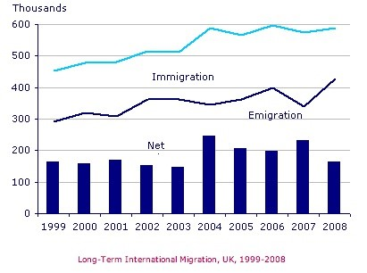

范文：

The chart gives information about UK immigration, emigration and net migration between 1999 and 2008.

Both immigration and emigration rates rose over the period shown, but the figures for immigration were significantly higher. Net migration peaked in 2004 and 2007.

In 1999, over 450,000 people came to live in the UK, while the number of people who emigrated stood at just under 300,000. The figure for net migration was around 160,000, and it remained at a similar level until 2003. From 1999 to 2004, the immigration rate rose by nearly 150,000 people, but there was a much smaller rise in emigration. Net migration peaked at almost 250,000 people in 2004.

After 2004, the rate of immigration remained high, but the number of people emigrating fluctuated. Emigration fell suddenly in 2007, before peaking at about 420,000 people in 2008. As a result, the net migration figure rose to around 240,000 in 2007, but fell back to around 160,000 in 2008.